**ENGINEERING JOURNAL TEMPLATE**

# 25/01/20

# Tasks:

* Jan 13 – Jan 27 fully complete the sensor. Receive signal from it that could be sampled and used with esp32 MCU

# Reflection:

* After my demo in college, I realized that if I continue with the same circuit I will be short on time and not be able to deliver my project on time. I decided to start over with a more simple circuit. Before I started building an oscillator from quad op-amp I had found a circuit where 555 timer was used to detect metallic objects. I decided to use the very same circuit. Some modification was required on the circuit. Originally circuit was making sound and sound frequency was changing when a metallic object is be said coil.
* I used circuit showin in Fig1. Tis cirquit was using speaker to notifie user about metallic object under coil L1. I modified this cicuit for use with micro controller. Modified cirquis is shown in Fig2. Modifications I added is op-amp as smitts triger for nice squre wave output and second op amp as buffer with 3.3 volts power input. Imput will be used with esp32 gpio inputs which works at max 3.3volts.

# Issues:

*Hardware:*

1. Building a circuit didn’t challenge me, but on modification, I had to think about how I will go about it. I tried adding first and second-order filters but I had on output 10 to 20 mV of noise and if I amplify, the signal will be useless. For a few days, I was looking for an approach to this issue. I was going back to my electronics tutorial from “EEVblog” he has a brilliant tutorial on Schmitt trigger. After watching the tutorial I implemented it and I getting a very nice square waveform now. Which I will use on MCU.
2. 555 cicuit was outputting squere like waveform with spikes at beginning of each change(Fig3 chanal 2). I observed that change in voltage loks like sharp 90 degre. After aplaying op-amp setuped as smitts trigger, waform changed to squerewave. For safe signal application on MCU I used second op-amp as buffer running from 3.3v power rail. Prototype was soldered on strip board (Fig5) and tested, outputs visible in Fif3 and Fig4.

# Solutions:

*Hardware:*

* The solution to my issue was solved by adding Schmits trigger with hysteresis. This way I was able to convert the unusable signal to usable

# Figures:

Fig1 Metal sensor by using 555 timer

Fig2 Medified cirquit

Fig3 Top buffer output, Botom 555timer output

Fig4 Top buffer output, bottom shmitts trigger output

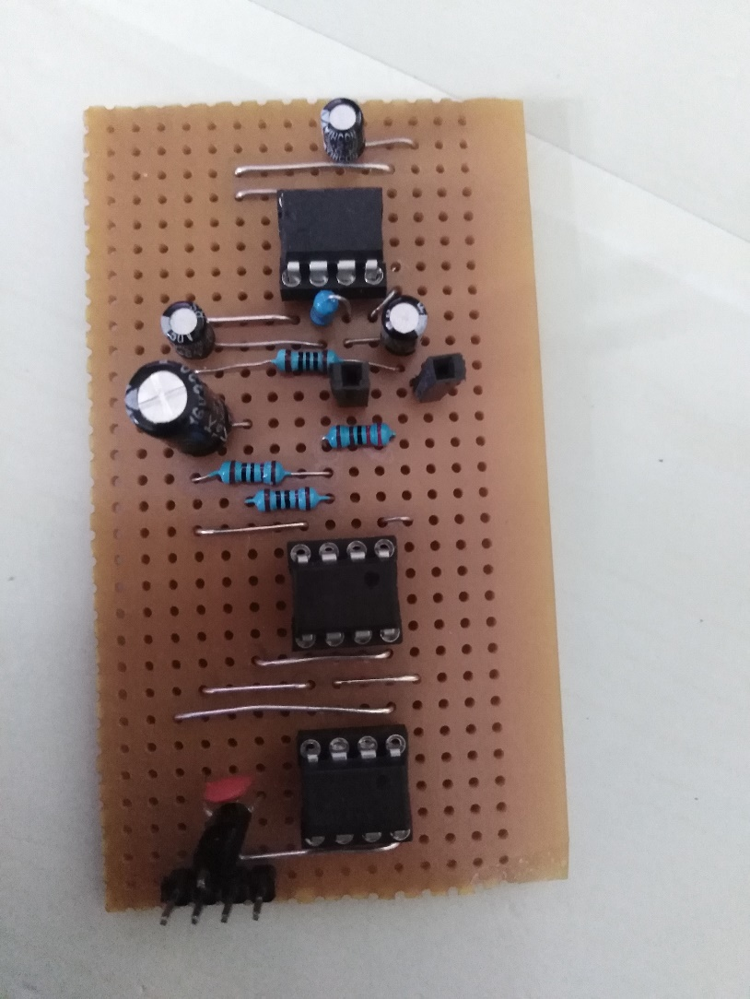

Fif5 Prototype_1